Gravity Explorer – Setup

Setting up Eclipse
To develop your application via Eclipse, you need to install the following pieces of software. You can find an in depth guide HERE.
- Java Development Kit 7+ (JDK) (6 will not work!)
- Eclipse, the "Eclipse IDE for Java Developers" is usually sufficient.
- Android SDK, you only need the SDK, not the ADT bundle, which includes Eclipse. Install the latest stable platforms via the SDK Manager.
- Android Development Tools for Eclipse, aka ADT Plugin. Use this update site: https://dl-ssl.google.com/android/eclipse/
- Eclipse Integration Gradle, use this update site: http://dist.springsource.com/snapshot/TOOLS/gradle/nightly (for Eclipse 4.4) or http://dist.springsource.com/release/TOOLS/gradle (for Eclipse < 4.4)
To additionally target iOS
- A Mac, iOS Development does not work on Windows/Linux thanks to Apple.
- The latest XCode, which you can get from the Mac OS X App Store for free
- RoboVM, simply install the Eclipse plugin. Make sure to update the plugin frequently!
Link: https://github.com/libgdx/libgdx/wiki/Setting-up-your-Development-Environment-%28Eclipse,-Intellij-IDEA,-NetBeans%29

Getting the Project
Checkout the gravity-explorer project from google code.
svn checkout http://gravity-explorer.googlecode.com/svn/trunk/

Link: https://code.google.com/p/gravity-explorer/source/checkout

Importing the project
Open Eclipse with “trunk/eclipse-workspace-new” as workspace.
- Click “File->Import->Gradle->Gradle Project”, new window opens.
- Set “eclipse-workspace-new/gravity-explorer” as “Root folder”.
- Uncheck “Run after”. More reading why http://stackoverflow.com/questions/23050695/null-pointer-importing-gradle-project-into-eclipse
- Click “Build model” and check all projects, then click “Next”.
When done, the package explorer should be populated with gravity-explorer, gravity-explorer-android, gravity-explorer-core, gravity-explorer-desktop and gravity-explorer-ios.
Next we want to import our texture packer program. To do this
- Click “File->Import->General->Existing Project into Workspace”, new window opens.
- Set “eclipse-workspace-new” as “Root folder”.
- Select “gravity-explorer-texturepacker” and click next.
Everything needed should now present in Eclipse's package explorer. That is:
gravity-explorer
gravity-explorer-android
gravity-explorer-core
gravity-explorer-desktop
gravity-explorer-ios
gravity-explorer-texturepacker
One last now remains, for gravity-explorer-desktop to find resource files, its run configuration needs modifications.
- Go to “Run->Run Configurations” .
- Select “DesktopLauncher” under “Java Applications and open the “Arguments” tab.
- Set “Working directory” to “Other”
- Click “Workspace” and select gravity-explorer-android's “assets” directory and Click Ok.
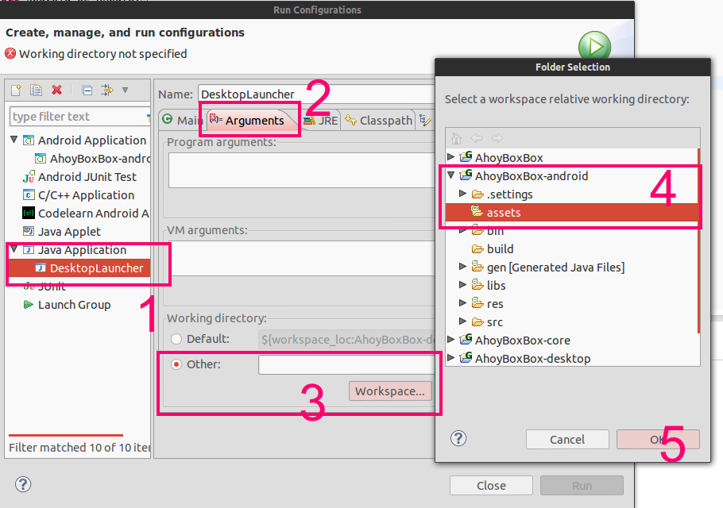
Link: http://stackoverflow.com/questions/22822767/new-libgdx-setup-receive-file-not-found

